No. | INSTRUCTIONS |  | KEY POINTS / CONTACTS
1. | Check out all humidifier filters. | 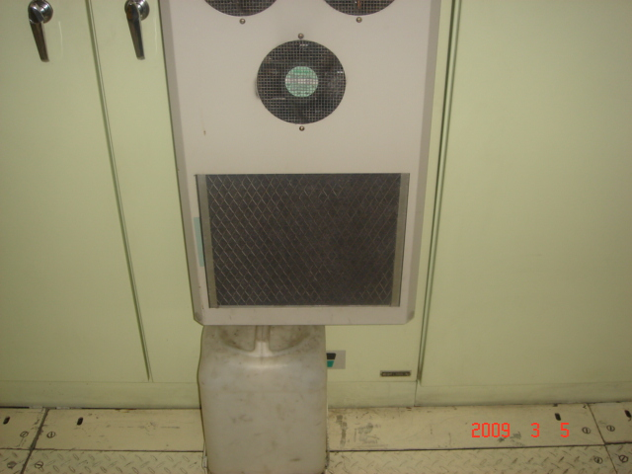 | ENSURE PERSONNAL PROTECTIVE EQUIPMENT (PPE) IS WORN: -  1. HARD HAT  2. STEEL CAP BOOTS  3. EYE PROTCTION  ENSURE LOCK- OUTS AND SAFETY BLOCKS ARE USED AT ALL TIMES.
2. | Remove filter by lifting it up and out.  If the filter is dirty, cut out new filters from material roll kept in the stores. | 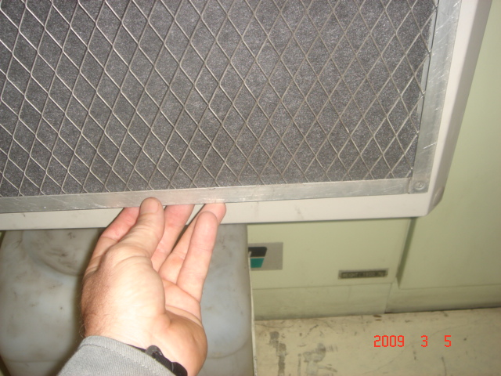 | 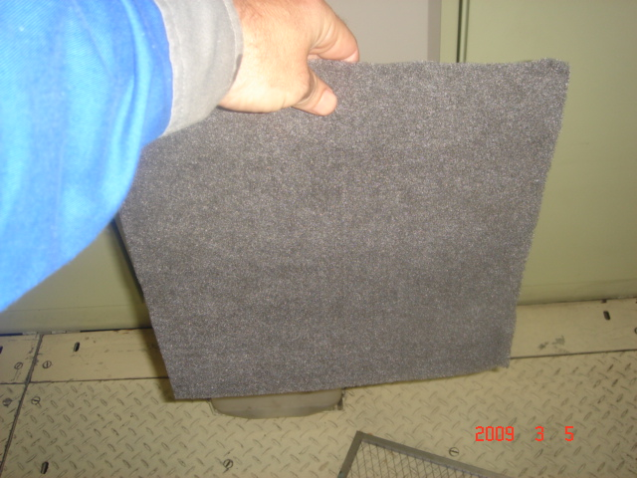
3. | Lock out the filter and blow out any dust from components,  Use a dusk mask. | 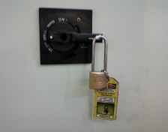 | 